**Database Systems Class Project Final Report**

**CSCI 3700/6070 Database Systems Spring 2020**

**IMDB DATABASE APPLICATION USING THE MVC ARCHITECTURE**

A PROJECT REPORT

Presented to the Department of Computer Science

Auburn University at Montgomery

In Partial Fulfillment

of the Requirements for the Degree

Master of Science in Computer Science

By

Krishna Chaitanya Kandimalla

Shashank Palusa

Kundhana Reddy Aavula Bala

Gutlapalli Venkata Ganesh

Thaneesh Reddy Veluru

# Introduce your database design (e.g. ER diagram, database schema etc.)

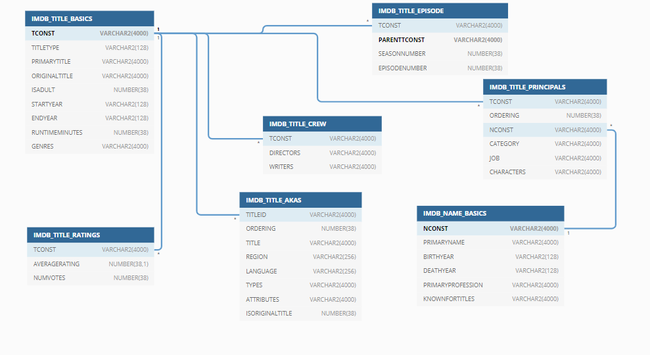

# Introduce your application design (e.g. MVC model, UML mode, etc.)?

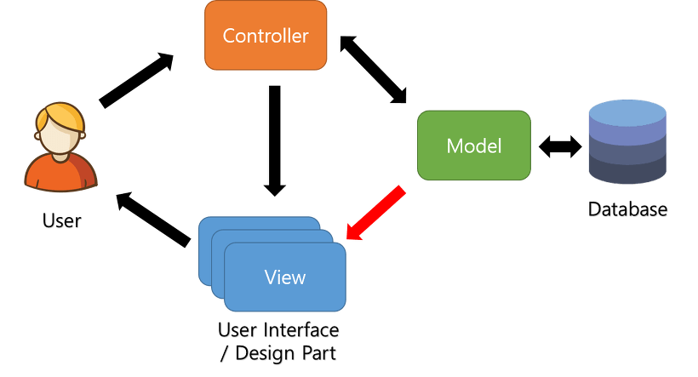

***MVC model design***

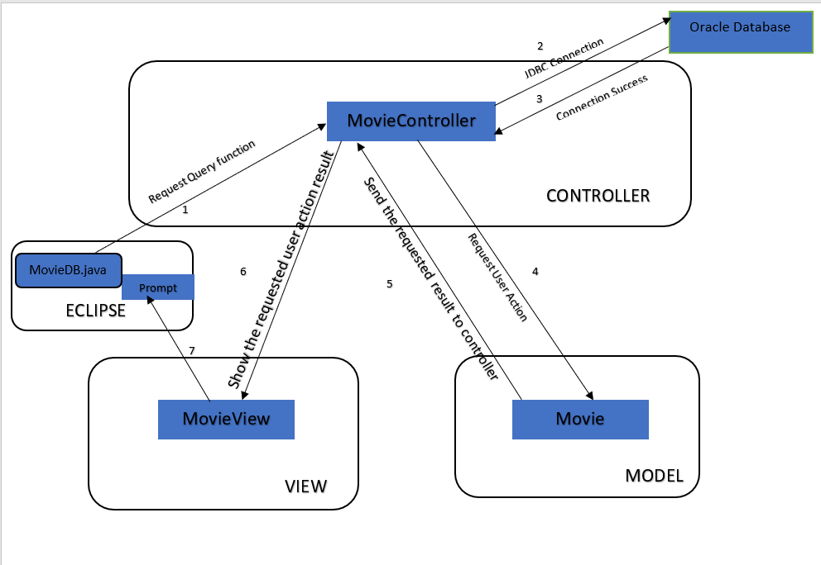

***Our MVC Model***

# List any technology that is not mentioned in the project description (e.g. Indexing, Caching, etc.)

We Have used python 3.6.4 to handle the null values.

# Please attach your codes (application) or a GitHub link to your project along with this report.

We created a GitHub link to access all our files related to project which include queries, java codes for application, README file for our MVC <https://github.com/Class-Project-Groups-7/CSCI-6070-Advanced-Database-Systems-Class-Project-Group-7>

# Individual tasks

|  |  |
| --- | --- |
| Student Name | Major tasks |
| Shashank Palusa | * Responsible for Setting up the environment for the project i.e. Downloading the given datasets for the project from online database, installing SQL developer and oracle database. * Responsible for MVC - Model.java and MovieView.java which explains creating Models and views to present data * Helped in connecting oracle MySQL Developer with eclipse * Helped with power point for final presentation * Worked on live demo |
| Kundhana Reddy Aavula Bala | * Responsible for designing Database schema and in logically grouping tables, views and stored procedures. Helped in importing data to the database using SQL developer. * Responsible for MVC – MovieController.java and MovieDb.java * Responsible for creating connection and controls to get data from database along with calling the 7 functions created to possibly run the command prompt application. * Worked on connecting oracle MySQL Developer with eclipse * Responsible for power point of final project presentation * Helped with live demo for final project presentation * Worked on the final report documentation |
| Gutlapalli Venkata Ganesh | * I converted the TSV files to CSV files while importing data errors will occur to eliminate those errors, I used python code to convert from TSV to CSV. * Used python to handle null values. * Helped with power point for final presentation. * Helped with live demo for final project presentation |
| Thaneesh Reddy Veluru | * Understanding the Imported data in the database and its hierarchy with the help of database schema. * Designing the required queries for the given questions in the project with bonus questions. * Establishing Connection in eclipse to run the Java Code * Helping with the final report Documentation |
| Krishna Chaitanya Kandimalla | * Importing the Converted (csv) files using SQL developer * Designing the required queries for the given questions in the project with bonus questions. * Created the VIEW for all the QUERIES * Executing the queries by handling it without any errors to get the required outputs. * Documenting the screenshots of the outputs for Submission. |

# 6. Functions (take screenshots from your apps, not from MySQL) (Section 2.3)

* 1. Show the information of movies (Title, Region, Language, Year, Rating, Votes) which have average rating greater than 7 and number of votes greater than 1000.

Screenshot:

* 1. Show the names of persons who have directed more than 10 movies.

Screenshot:

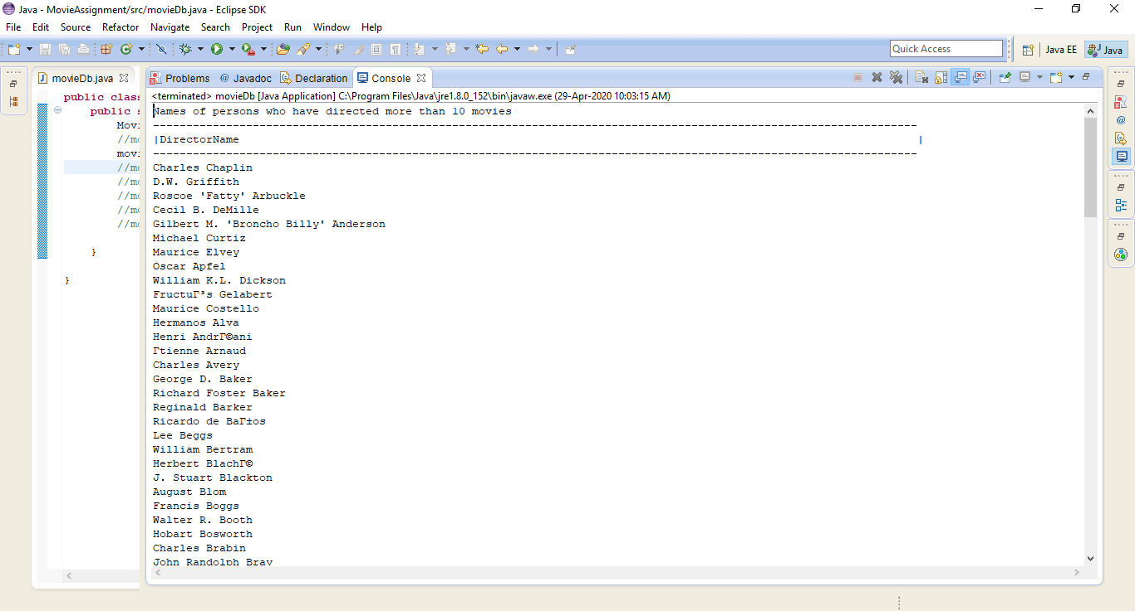

* 1. Show the top 10 TV series (more than 1 season) which most average ratings.

Screenshot:

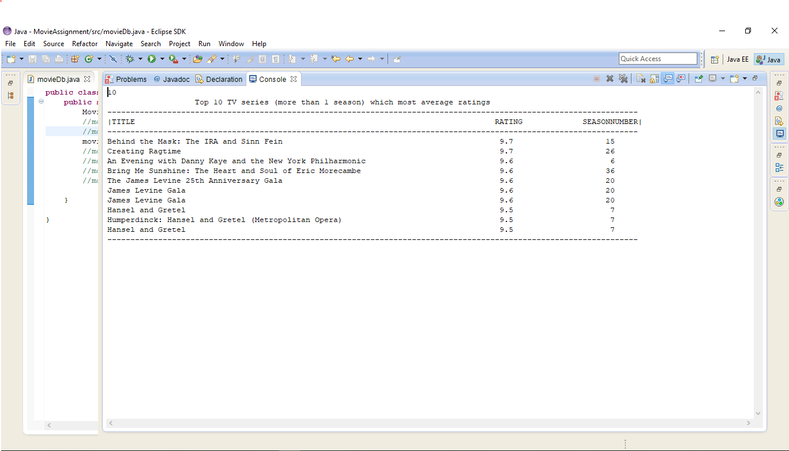

* 1. Optional 4 more queries which satisfy

1. Use aggregate functions, “group by” and “order by”.
2. Use set operations.
3. Use nested/sub queries (either in SELECT clause, FROM clause or WHERE clause).
4. Use JOIN operations.

Screenshot 1:

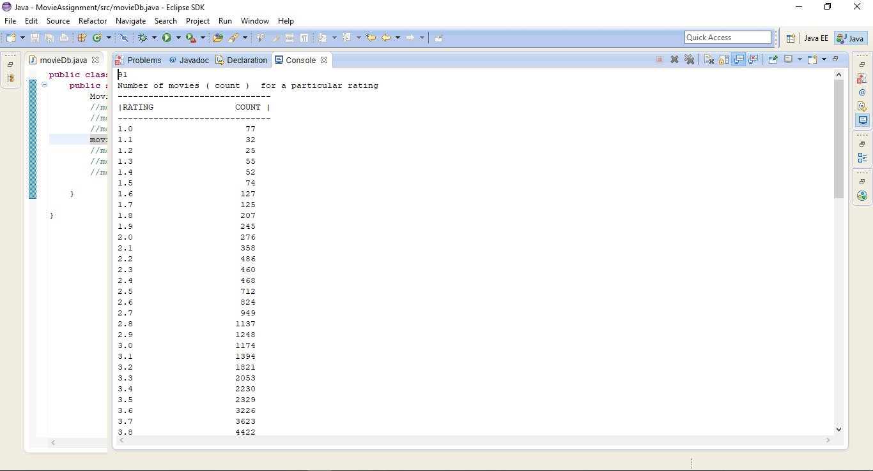

Screenshot 2:

Screenshot 3:

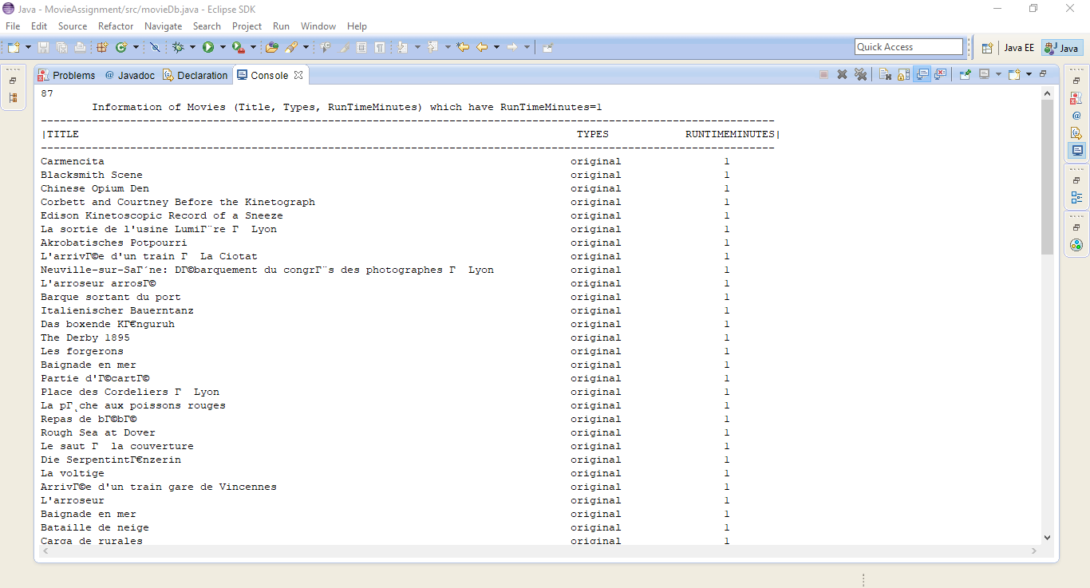

Screenshot 4:

